7. Implementation details

**7.01 Working procedure**

Knapsack algorithm : knapsack algorithm is a greedy algorithm . in this algorithm ,you are given some weight and value of something. And you have a limit capacity of bag. You have to fill the bag as you value is max. so this type of problem is solved by knapsack algorithm.

This algorithm is work like ,you will take one item and don’t take the item and calculate the value of the taken item . this algorithm will give you the max price or value of a item.

In our project we use this algorithm to find the best house for a user. We rate every house in the apps and we will using knapsack using this rating.

First we take rating as price in knapsack and rent as weight. So that we can maximize the price and minimize the rent. For capacity we calculate a number using rent . so knapsack will select those house which rating is good for the user. By default we will select only five best house in our app as user will not be disturbed of finding house.

Merge sort : we will also use sorting for finding the all house in user capacity. Merge sort is working divide and conquer procedure.

First the unsorted array will divide into two parts using recursion. This procedure will apply until there is one element in the sub-array. Then it will compare the two sub-array and swap them. Then it will merge together. This merging will continue until whole array will get.

In our project we use this sorting algorithm for sort the rent of the house. The rent will sort according the range of the rent which will give by the user. Then he will find the all house in his/her selected area.

**7.02 Experimental result :**  The output of our project is given below

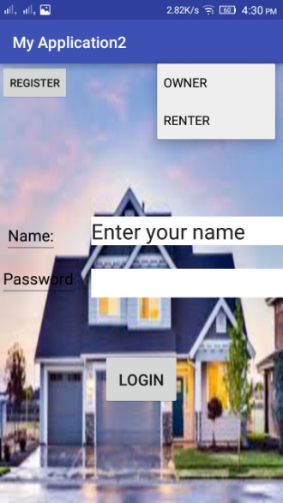1.this is the first page of the apps. You can find many things here. A user can register here for a new account .if he select register button , next register page will appear.

If a user have already an account ,he will select owner or renter for login. Then he will give her name and password and press the login button . if he has no account then a toast will appear and say User doesn’t exists”. If user has an account then say “Welcome X ”.

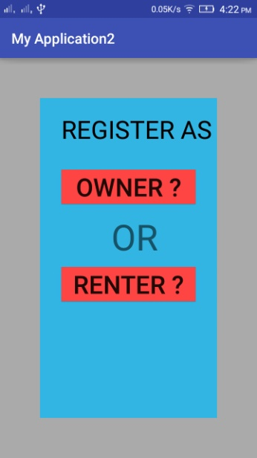2. if a user have no account in the app then he will select the register button .then this page will appear. Here he can see two button. One is for owner and another is for renter. User will select one button for his need.

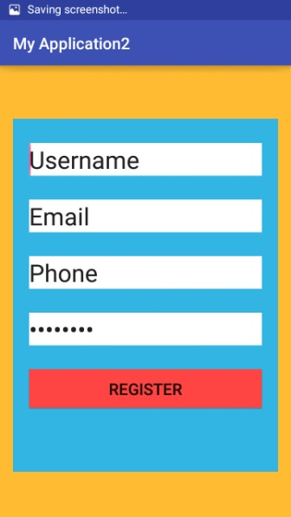3. if user will select owner button for registration ,this page will appear. In this page he have to fill all the information login. Then click register button for completing his registration.

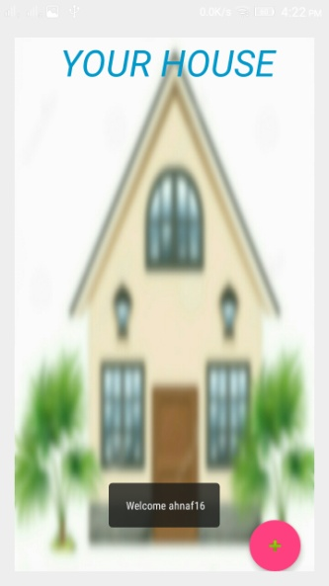4. if a owner register or login in the apps this page will appear. In the page the post of his /her house will displayed. If user want to add more house then he will select “+” floating button under the page. Then next page will appear.

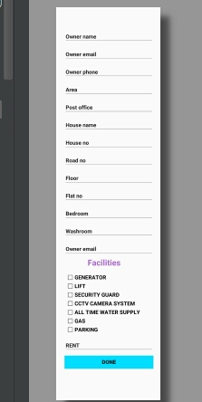5. if a owner select add button to add more house for rent then this page will appear. In this page there are many information of a owner and about his house. He must fill all the information and set the rent of her house. Then he will select done button . then the information of the house will show in the step 4.

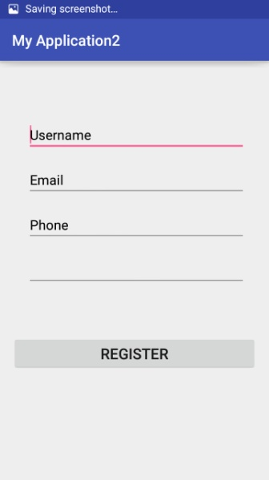6. when a user select the register button and select the renter then this page will appear. Then he have to fill the information and press the register button.

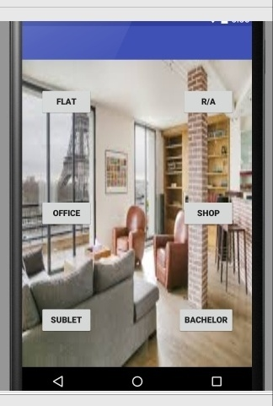7. this page will appear when a renter logged in or register. Here he can find many option . he will select his/her desired button for going to next page.

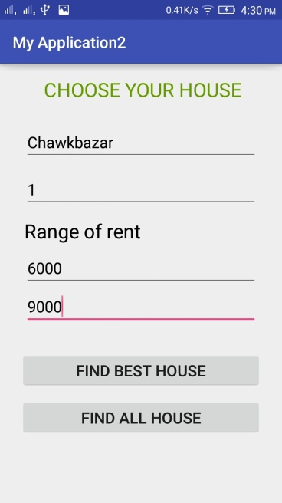8. if a renter select the R/A in step 7 then he will appear this page. Then he have to fill the information and select what kind of process he like. Of he find the best house then select first button or select he second button.

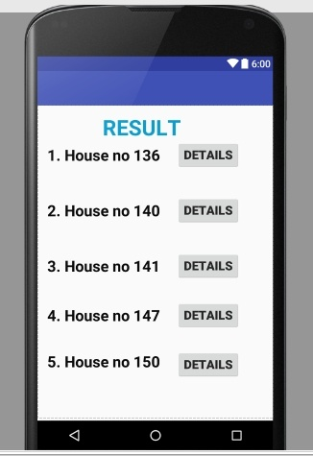9. it’s the main key of our project. Here a renter can find the best house considering his need. He can see the details of the house using details butoon.

**8.0.3 Comparison with existing work**

|  |  |
| --- | --- |
| **Our work** | **Related work** |
| Our work will find the best house for the user | To-let will show the all house in the apps. |
| User can search his area according his need | User can not search his area |
| User can select a range of rent | User cant select range of rent. |
| User can select number of bedroom. | User cant select number of bedroom |
| Processing of maintenance is easy | Processing of maintenance is difficult |

**10 .conclusion**

Today’s finding house for a renter is so difficult. This apps will remove this problem of finding a house. This process a user can easily find a house for his own requirement. This apps will also helps the owner for give to to-let of his house. As to days world is technology depended ,so this apps will remove the problem of a renter of finding a house . this apps will also useful for those who want to sell flat, shop and most importantly this will helpful for sublet and bachelor section.

**11. Future recommendation**

the new features we can add :

1. We can design this system more beautifully.
2. We can use google map in future
3. Improvement of the algorithm
4. Use image of house for rent.